Testimonials
I would like to begin by stating that Hope & Healing at Hillenglade is a God-breathed organization. Jennifer has created a haven for veterans, who are in various stages of grief and pain. HHH’s goal is to restore the troubled veteran to a state of peaceful existence through Equine-assisted therapy. My personal experience with this process has enriched me above my expectations. There are no time limits at HHH. Veterans must have a place to go where barriers to healing are minimized…HHH in Nashville is such a place. Since my involvement with Jennifer and the HHH Staff, I have felt transformations of my heart and mind, which has restored my trust in humanity, and in my Creator. God’s footprint is visible all over Hillenglade. Jennifer has provided me strength and guidance continuously without regard for time constraints. Her sincere availability for veterans is unselfish, and her life is driven by service. It is with unwavering devotion that I endorse the mission and staff of Hope and Healing at Hillenglade.

~ Ray Valentine, 1st Infantry Division/Infantryman
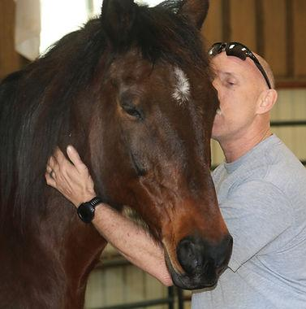
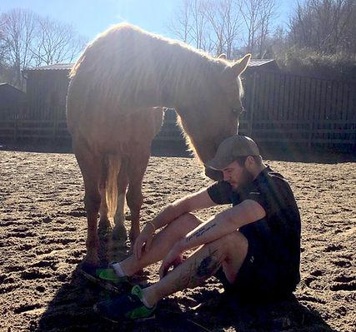
In 2020, I came to Hope and Healing at Hillenglade from the VA after an attempted suicide. Working with the staff and horses was great. The sessions seemed to put my mind at ease. It helped me relax and I could take some of the lessons with the horses and use them for coping skills and focus. Plus, when the animal gives you all its trust, it really makes you whole again. I now work at HHH as the Farm Manager. I want to help others heal by spending time with our rescue horses and donkeys.

~ William Bentrem, Specialist, US Army
Gianna loved working with horses JB and Bunny at her first visit to the farm. It was a great escape from the difficulties in our life right now after losing my husband and Gianna’s dad in service. We are extremely appreciative of the opportunity to visit HHH and the generosity of Jennifer’s organization and staff.

~ Danielle and Gianna Marketta
A few years ago, I decided to come off of all of my Psychotropic drugs – I have taken some type of substance from the Military or VA since 1986. When I came to HHH, I just decided to let whatever happens happen and avoid trying to control anything. The horses helped me receive something that I didn’t expect. They gave something to me that I haven’t been able to get in my counselor’s office. Thank you, HHH, for taking the time to allow God to work with me through the horses.

~ Darren Melching, Retired US Marine
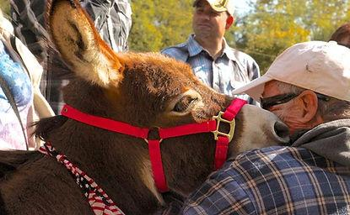
After reading a testimonial on the positive effects of Equine Therapy, I reached out to Jennifer O’Neill at Hope & Healing at Hillenglade to see about bringing my boys out to help them process the loss of my brother-in-law, and to understand the impact grief was having on their mother. The time the boys and I spent with Jennifer, Morgan, Billy, and the horses created an opportunity for the boys and I to have a really meaningful discussion about our family and our feelings. What was unexpected was how much I needed to be there to help me deal with my own emotions. Thank you, Jennifer. I loved that you were so passionate about wanting to help our family. I can’t wait for us to come back again.
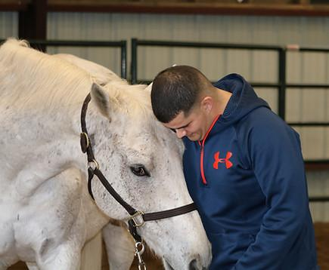
What you’ve created for the Nashville and Veteran community at Hillenglade is the epitome of charity and serving God. I support this cause 100% and I look forward to seeing it grow, the chapel build is exciting and I’d enjoy attending service. When my mother comes into town this summer you can count on us coming by, I’d like to rent a suite for her there, so she can spend the night. She will love that, she served the navy too.” God bless you and talk again soon.

~ N. Warren Steury
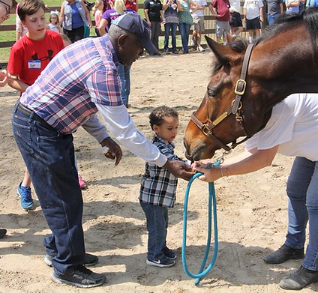

~ Blaine Harvey, Retired Command Sargent Major, US Army
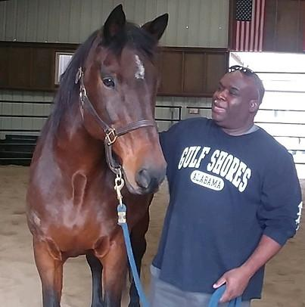
Jen, your latest HHH event, as always, was a warm, relaxing, joyful gathering of Heroes who had the privilege of being honored by you and the HHH Team with food, music, games and a healing ambiance…

~ Tia Acosta, MD Specialist in PTSD
We had a fantastic time with the Hillenglade family. It was just a blessing to see Jen work with my family and the horses. My husband, Charles, really had a good time; he had not been smiling like that in a loooooong time.
​

~ Dee Waters, US Army
Thank you for arranging such a superb program … I look forward to helping you with your future events.

~ Lt. General Hugh Smith, Retired
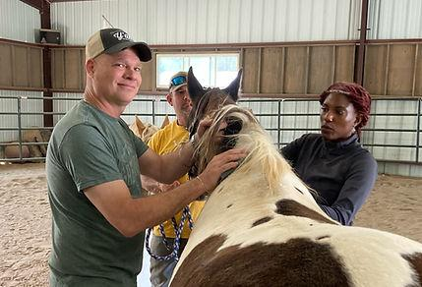
Everyone at Hillenglade thanked us over and over for our military service, and loved on our kids like they were their own. It was so amazing.

~ Rachel J., Military Wife
Jen, thank you for your support of Veterans and their families through your programs, especially those suffering the effects of PTSD. We look forward to recognizing your great work at our Region III Banquet with a special award for your HHH efforts!

~ Barry Rice, President/TN. State Council/Vietnam Veterans of America
The therapeutic effects of the horses on victims of PTSD is remarkable, according to O’Neill. “Horses are such gentle giants – Warriors relate to them because they are so powerful, and yet they have a keen sense of communication. They are magical animals with a calming effect…
” Dr. Marc Siegel, professor of medicine at NYU Langone Medical Center and a Fox News contributor said, “Horses are absolutely therapeutic. I believe this.”

~ Cristina Corbin, New York-Based Reporter for FoxNews.com
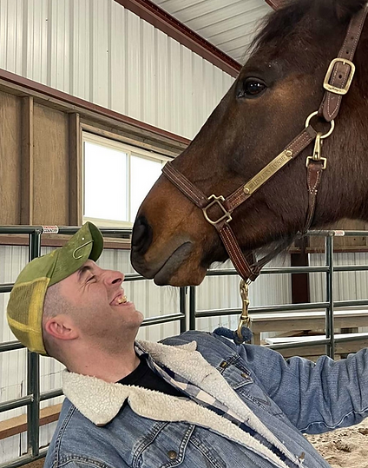
“The horses are mirrors to our behavior, and I found out very quickly how wound up I am from 23 years of emergency calls. Although I wouldn’t characterize it as full blown PTSD, I would say it’s a big dose of hypervigilance that I have. The horses helped with that. It was pretty magical! Jen teaches how to be a horse handlers as well. I was truly humbled and amazed at the opportunity I was given”

~ Sean Garrison, Third Watch Band
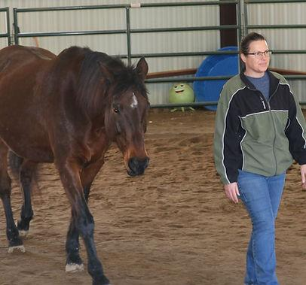
My name is Mark DeLuzio, and I am a Gold Star Father, having lost my son, Steven, who was killed in action in Afghanistan in 2010. I have started an outreach program to provide business and career advice to Veterans. This free service is called B.R.A.V.E. (Business Reviews and Advisors to Veteran Entrepreneurs) (www.4thebrave.org). B.R.A.V.E. also provides business advice to organizations designed to assist Veterans with various issues that they face. One of the most serious today is PTSD and suicide.
Early this year, I was fortunate to meet actress and author, Jennifer O’Neill.
I learned that Ms. O’Neill runs a horse farm in Nashville called Hope and Healing at Hillenglade (HHH).
Since 2010, Ms. O’Neill has hosted over 4,000 Veterans and their families, including Gold Star Families suffering from their own PTSD. These guests at HHH experienced equine therapy’s magic, and the stories that I have heard have been nothing but remarkable. However, I had to see for myself, so I recently visited Ms. O’Neill’s farm and saw her in action. Ms. O’Neill ran an equine session with one of her rescue horses and a Veteran named Billy, who is suffering from severe PTSD. As Billy developed a relationship with the horse, it was clear that he alleviated his stress and became self-aware of the signals he was transmitting to the horse. Billy later responded that this one session would go a long way in helping him improve his interpersonal skills with family and friends. Right before my very eyes, I saw Billy’s transformation. I am personally devoting my time and B.R.A.V.E. resources to advance Ms. O’Neill’s outstanding and much-needed work to our nation’s heroes. We lose well over 22 Veterans daily to suicide. If we can save one life, my time with HHH will be more than worth the investment.

~ Mark DeLuzio
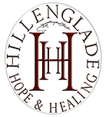
20 Hillenglade Drive Nashville, Tennessee
37207

About Us

